procedures following lift of boil water order/advisory

**Applicable to**: All water circuits, spray stations, beverage dispensers, brewers, ice machines, water softeners, water holding tanks and filtration systems in Restaurants affected by a Boil Water Order/Advisory.

**Maintenance Performed by:** Qualified service professional or experienced Team Member.

**CAUTION**

• All procedures must be performed **after** the Boil Water Order/Advisory has been lifted by the local or state Health Department.

• Procedures listed below must be **performed in the order shown**. Failure to comply may recontaminate potable water supplies.

• Restaurants with water softeners, Tea Nano water systems, Nano water systems, or reverse osmosis water systems will require a certified water filtration service provider to sanitize and **restart** this equipment. Contact Strategic Equipment at 866-324-4253 EXT. 5 for a referral.

• Ensure you have new filters and O-rings on hand **first** before performing procedures.

**Filters Only (Type I)**

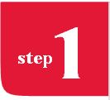 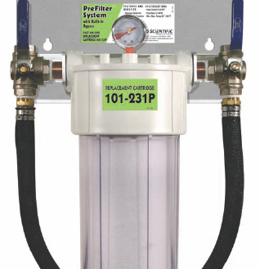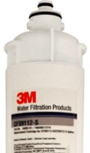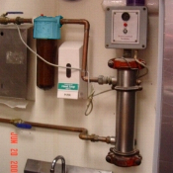

Ensure You Have New Filters & O-Rings

**Team Member Task**

Order replacement filter cartridges from Strategic Equipment at 866-324-4253 EXT. 5. Filter bowl O-rings must be included in the order. The replacement cartridge ID for bowl-type filters from Selecto and Everpure is identified with a label on the “head” of the filter housing or on the body of the bowl. The cartridge ID for filters without bowls

is printed directly onto the cartridge. Note: For Restaurants with Scalemaster systems, 10" post filter must also be replaced.

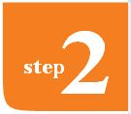 Remove Old Filters & Flush Lines

**Team Member Task**

• Ensure that filter systems are bypassed or the incoming water is shut off before attempting to remove any cartridge.

• Remove and discard all water filters (Carbon, IcePRO, ScaleOUT, IM620, CoffeePRO, prefilter, SR-X, Scalemaster). Sanitize filter bowls with KAY-5 sanitizer. Replace filter bowls without filters. For Everpure systems leave filter system in bypass after removing cartridges.

• Discard all ice from ice maker bins and beverage tower ice bins.

• Plug all carbonator pumps in

• Open all water circuits (hot and cold) at hand sinks, 3-compartment sinks, veggie prep sink,

mop sink, filtered water faucet and spray stations. Run continuously for 30 minutes. Open each beverage dispensing valve and water dispenser at each beverage tower and run each for 2 minutes.

• Open bypasses to filter system. Allow city water to flush filter bypasses for 10 minutes.

• Run coffee and tea brewers for 2 complete brew cycles. Discard water.

• Clean and sanitize Hoshizaki ice machines by following the instructions on the inside cover of the ice machine. Use only Hoshizaki approved sanitizer. Run cuber ice machine through 3 ice making cycles. Run cubelet ice machine for 20 minutes of ice production. Discard all ice. Contact Hoshizaki Tech Support at 800-233-1940.

• Clean and sanitize underside of ice machine, ice bin and all ice bins at beverage towers.

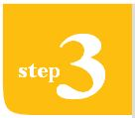 Install New Filters

**Team Member Task**

• Install new filter cartridges (Carbon, CoffeePRO, IcePRO, ScaleOUT, IM620, prefilter, SR-X, Scalemaster). Flush all carbon filters and CoffeePRO to drain for 5 minutes each. For filters without flush valves contact Chick-fil-A Facilities and Equipment line at EXT. 58998 for further instructions.

• Disconnect inlet water line on back of coffee and tea brewers. Open water stop and flush water lines to drain for 10 minutes to remove all air from the water lines. Reconnect inlet water line to each brewer.

• Run coffee and tea brewers for 2 complete brew cycles. Discard water.

• Open each beverage dispensing valve and water dispenser at each beverage tower and run each for 2 minutes.

• Open the Filtered Water Faucet and run continuously for 2 minutes.

In addition, be sure to perform the following:

• Clean and sanitize interior of ice machines, bins, ice buckets and scoops

• Discard the entire first batch of ice before serving customers

• Clean and sanitize all sinks and ice bins in FOH before use

• Clean and sanitize all fixtures, sinks (3-compartment, handwashing, produce and restrooms) and other equipment connected to water lines

• Confirm with local Health Department that any other procedures that are required are completed