procedures following lift of boil water order/advisory

**Applicable to**: All water circuits, spray stations, beverage dispensers, brewers, ice machines, water softeners, water holding tanks and filtration systems in Restaurants affected by a Boil Water Order/Advisory.

**Maintenance Performed by:** Qualified service professional or experienced Team Member.

**CAUTION**

• All procedures must be performed **after** the Boil Water Order/Advisory has been lifted by the local or state Health Department.

• Procedures listed below must be **performed in the order shown**. Failure to comply may recontaminate potable water supplies.

• Restaurants with water softeners, Tea Nano water systems, Nano water systems, or reverse osmosis water systems will require a certified water filtration service provider to sanitize and **restart** this equipment. Contact Strategic Equipment at 866-324-4253 EXT. 5 for a referral.

• Ensure you have new filters and O-rings on hand **first** before performing procedures.

task description by filtration type

**Filters Only (Type I)**

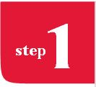 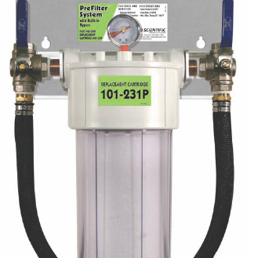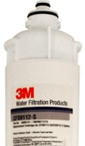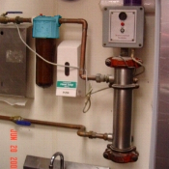

Ensure You Have New Filters & O-Rings

Team Member Task

Order replacement filter cartridges from Strategic Equipment at 866-324-4253 EXT. 5. Filter bowl O-rings must be included in the order. The replacement cartridge ID for bowl-type filters from Selecto and Everpure is identified with a label on the “head” of the filter housing or on the body of the bowl. The cartridge ID for filters without bowls

is printed directly onto the cartridge. Note: For Restaurants with Scalemaster systems, 10" post filter must also be replaced.

 Remove Old Filters & Flush Lines

Team Member Task

• Ensure that filter systems are bypassed or the incoming water is shut off before attempting to remove any cartridge.

• Remove and discard all water filters (Carbon, IcePRO, ScaleOUT, IM620, CoffeePRO, prefilter, SR-X, Scalemaster). Sanitize filter bowls with KAY-5 sanitizer. Replace filter bowls without filters. For Everpure systems leave filter system in bypass after removing cartridges.

• Discard all ice from ice maker bins and beverage tower ice bins.

• Plug all carbonator pumps in

• Open all water circuits (hot and cold) at hand sinks, 3-compartment sinks, veggie prep sink,

mop sink, filtered water faucet and spray stations. Run continuously for 30 minutes. Open each beverage dispensing valve and water dispenser at each beverage tower and run each for 2 minutes.

• Open bypasses to filter system. Allow city water to flush filter bypasses for 10 minutes.

• Run coffee and tea brewers for 2 complete brew cycles. Discard water.

• Clean and sanitize Hoshizaki ice machines by following the instructions on the inside cover of the ice machine. Use only Hoshizaki approved sanitizer. Run cuber ice machine through 3 ice making cycles. Run cubelet ice machine for 20 minutes of ice production. Discard all ice. Contact Hoshizaki Tech Support at 800-233-1940.

• Clean and sanitize underside of ice machine, ice bin and all ice bins at beverage towers.

 Install New Filters

Team Member Task

• Install new filter cartridges (Carbon, CoffeePRO, IcePRO, ScaleOUT, IM620, prefilter, SR-X, Scalemaster). Flush all carbon filters and CoffeePRO to drain for 5 minutes each. For filters without flush valves contact Chick-fil-A Facilities and Equipment line at EXT. 58998 for further instructions.

• Disconnect inlet water line on back of coffee and tea brewers. Open water stop and flush water lines to drain for 10 minutes to remove all air from the water lines. Reconnect inlet water line to each brewer.

• Run coffee and tea brewers for 2 complete brew cycles. Discard water.

• Open each beverage dispensing valve and water dispenser at each beverage tower and run each for 2 minutes.

• Open the Filtered Water Faucet and run continuously for 2 minutes.

In addition, be sure to perform the following:

• Clean and sanitize interior of ice machines, bins, ice buckets and scoops

• Discard the entire first batch of ice before serving customers

• Clean and sanitize all sinks and ice bins in FOH before use

• Clean and sanitize all fixtures, sinks (3-compartment, handwashing, produce and restrooms) and other equipment connected to water lines

• Confirm with local Health Department that any other procedures that are required are completed

**Filters with a Water Softener (Type II, Type I w/POU Tea softener)**

 

Ensure You Have New Filters & O-Rings

Team Member Task

Order replacement filter cartridges from Strategic Equipment at 866-324-4253 EXT. 5. Filter bowl O-rings must be included in the order. The replacement cartridge ID for bowl-type filters from Selecto and Everpure is identified with a label on the “head” of the filter housing or on the body of the bowl. The cartridge ID for filters without bowls

is printed directly onto the cartridge. Note: For Restaurants with Scalemaster systems, 10" post filter must also be replaced.

 Sanitization of Softener(s)

Service Agent Task

• Add 1 cup of KAY-5 sanitizer (Green Pack) to water softener brine tank. Add sanitizer directly to standing

water through the plastic stand pipe. Do not pour sanitizer directly onto the salt. For small point

of use softeners add 2 tablespoons of sanitizer through the brine tank stand pipe. Force controller into the regeneration cycle. After the regeneration cycle, calibrate the controller and set clock. Note: If power has been interrupted, the clock on the controller will not be correct, and may result in regeneration during business hours.

• Calibrate water softener to dose salt at the rate of 8 lbs. per cu. ft. of resin.

• Contact the CFA Facilities & Equipment line at EXT. 58998 for calibration specifications.

Costs & Billing

• The cost of filters, salt, sanitizer plus labor for installation, sanitation and calibration of equipment will be refunded to the Restaurant via TBR to the Equipment Group at Chick-fil-A headquarters. Indicate “boil Water Order/Advisory” on the notes section of the TBR.

 Remove Old Filters & Flush Lines

Team Member Task

• Ensure that filter systems are bypassed or the incoming water is shut off before attempting to remove any cartridge.

• Remove and discard all water filters (Carbon, IcePRO, ScaleOUT, IM620, CoffeePRO, prefilter, SR-X, Scalemaster). Sanitize filter bowls with KAY-5 sanitizer. Replace filter bowls without filters. For Everpure systems leave filter system in bypass after removing cartridges.

• Discard all ice from ice maker bins and beverage tower ice bins.

• Plug all carbonator pumps in.

• Open all water circuits (hot and cold) at hand sinks, 3-compartment sinks, veggie prep sink,

mop sink, filtered water faucet and spray stations. Run continuously for 30 minutes. Open each beverage dispensing valve and water dispenser at each beverage tower and run each for 2 minutes.

• Open bypasses to filter system. Allow city water to flush filter bypasses for 10 minutes.

• Run coffee and tea brewers for 2 complete brew cycles. Discard water.

• Clean and sanitize Hoshizaki ice machines by following the instructions on the inside cover of the ice machine. Use only Hoshizaki approved sanitizer. Run cuber ice machine through 3 ice making cycles. Run cubelet ice machine for 20 minutes of ice production. Discard all ice. Contact Hoshizaki Tech Support at 800-233-1940.

• Clean and sanitize underside of ice machine, ice bin and all ice bins at beverage towers.

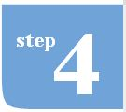 Install New Filters

Team Member Task

• Install new filter cartridges (Carbon, CoffeePRO, IcePRO, ScaleOUT, IM620, prefilter, SR-X, Scalemaster). Flush all carbon filters and CoffeePRO to drain for 5 minutes each. For filters without flush valves contact Chick-fil-A Facilities and Equipment line at EXT. 58998 for further instructions.

• Disconnect inlet water line on back of coffee and tea brewers. Open water stop and flush water lines to drain for 10 minutes to remove all air from the water lines. Reconnect inlet water line to each brewer.

• Run coffee and tea brewers for 2 complete brew cycles. Discard water.

• Open each beverage dispensing valve and water dispenser at each beverage tower and run each for 2 minutes.

• Open the Filtered Water Faucet and run continuously for 2 minutes.

In addition, be sure to perform the following:

• Clean and sanitize interior of ice machines, bins, ice buckets and scoops

• Discard the entire first batch of ice before serving customers

• Clean and sanitize all sinks and ice bins in FOH before use

• Clean and sanitize all fixtures, sinks (3-compartment, handwashing, produce and restrooms) and other equipment connected to water lines

• Confirm with local Health Department that any other procedures that are required are completed

**Filters with a Tea NANO (Tea NANO)**

 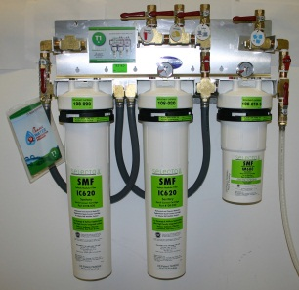 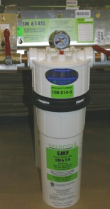

Ensure You Have New Filters & O-Rings

Team Member Task

Order replacement filter cartridges from Strategic Equipment at 866-324-4253 EXT. 5. Filter bowl O-rings must be included in the order. The replacement cartridge ID for bowl-type filters from Selecto and Everpure is identified with a label on the “head” of the filter housing or on the body of the bowl. The cartridge ID for filters without bowls

is printed directly onto the cartridge. Note: For Restaurants with Scalemaster systems, 10" post filter must also be replaced.

Service Agent Task

Order replacement membrane and hepa air filter directly from B&R Industries (Michael Kannapel) at 480-898-0008. Give them the restaurant’s Unit number and tell them this is a **Tea NANO** system.**.**

 Sanitization of Tea NANO

Service Agent Task

• Unplug the Tea NANO system from the wall outlet.

• Add **XXX** of KAY-5 sanitizer (Green Pack) to the 5 gallon green NANO water holding tank. **Fill** tank to brim full with city water. Allow the tank to sit undisturbed for 1 hour. Flush the tank using the delivery pump. Bypass the Tea NANO (located above the Selecto T-1 filter system.

• HOW DO WE DO THE INTERNAL HOLDING TANKS?

Do we run it “dry” before we start to disassemble?

• Remove membrane and sanitize the membrane housing and O-rings.

• Calibrate the Tea NANO (while it is running) by adjusting the Throttle Valve until the **REJECT** gauge reads 2.0 gpm. Contact the CFA Facilities & Equipment line at EXT. 58998 if you have any difficulty getting the Tea NANO to calibration specification.

 Remove Old Filters & Flush Lines

Team Member Task

• Discard all ice from ice maker bins and beverage tower ice bins.

• Plug all carbonator pumps in.

• Open all water circuits (hot and cold) at hand sinks, 3-compartment sinks, veggie prep sink,

mop sink, filtered water faucet and spray stations. Run continuously for 30 minutes. Open each beverage dispensing valve and water dispenser at each beverage tower and run each for 2 minutes.

• Run coffee and tea brewers for 2 complete brew cycles. Discard water.

• Clean and sanitize Hoshizaki ice machines by following the instructions on the inside cover of the ice machine. Use only Hoshizaki approved sanitizer. Run cuber ice machine through 3 ice making cycles. Run cubelet ice machine for 20 minutes of ice production. Discard all ice. Contact Hoshizaki Tech Support at 800-233-1940.

• Clean and sanitize underside of ice machine, ice bin and all ice bins at beverage towers.

Service Agent Task

• Ensure that filter systems are bypassed or the incoming water is shut off before attempting to remove any cartridge.

• Remove and discard all water filters.

 Install New Filters

Service Agent Task

• Install new filter cartridges. Flush all carbon filters (IC620’s) to drain for 5 minutes. For filters without flush valves contact Chick-fil-A Facilities and Equipment line at EXT. 58998 for further instructions.

• Install new membrane and reassemble Tea NANO cabinet

• Plug the Tea NANO system into the wall outlet.

What else to start it up again??

• Calibrate the Tea NANO (while it is running) by adjusting the Throttle Valve until the **REJECT** gauge reads 2.0 gpm. Contact the CFA Facilities & Equipment line at EXT. 58998 if you have any difficulty getting the Tea NANO to calibration specification.

• Disconnect inlet water line on back of coffee and tea brewers. Open water stop and flush water lines to drain for 10 minutes to remove all air from the water lines. Reconnect inlet water line to each brewer.

Team Member Task

• Run coffee and tea brewers for 2 complete brew cycles. Discard water.

• Open each beverage dispensing valve and water dispenser at each beverage tower and run each for 2 minutes.

• Open the Filtered Water Faucet and run continuously for 2 minutes

In addition, be sure to perform the following:

• Clean and sanitize interior of ice machines, bins, ice buckets and scoops

• Discard the entire first batch of ice before serving customers

• Clean and sanitize all sinks and ice bins in FOH before use

• Clean and sanitize all fixtures, sinks (3-compartment, handwashing, produce and restrooms) and other equipment connected to water lines

• Confirm with local Health Department that any other procedures that are required are completed

**NANO filtration system(Type III NANO)**



Ensure You Have New Filters & O-Rings

Service Agent Task

Order replacement membranes, cartridges, Granular Activated Carbon, and hepa air filter directly from B&R Industries (Michael Kannapel) at 480-898-0008. Give them the restaurant’s Unit number and tell them this is a **NANO** filtration system.**.** Filter bowl O-rings must be included in the order.

 Sanitization of NANO filtration system

Service Agent Task

• Unplug the NANO system from the wall outlet.

• Add 2 packets of KAY-5 sanitizer (Green Pack) to the green NANO water holding tank. **Fill** tank to brim full with city water. Allow the tank to sit undisturbed for 1 hour. Power-flush the tank using the delivery pump. Bypass the NANO system.

Do we run it “dry” before we start to disassemble?

• Remove membranes and sanitize the membrane housings and O-rings.

• Calibrate the NANO (while it is running) by adjusting the Throttle Valve until the **REJECT** gauge reads 3.5 gpm. Contact the CFA Facilities & Equipment line at EXT. 58998 if you have any difficulty getting the NANO system to calibration specification.

**Everpure Reverse Osmosis filtration system (Type III RO)**

 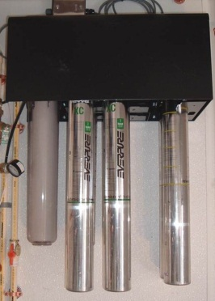 C:\Users\Craig Minor\Desktop\NEW RO TRAINING 02_23_12\RO_PRESENTATION_PIX\IN ORDER\RO-16.jpg 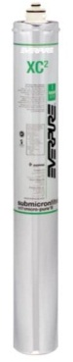 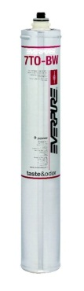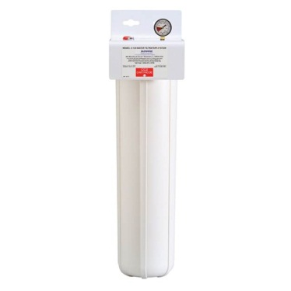

Ensure You Have New Filters & O-Rings

**Service Agent Task**

Order replacement membranes, filters, cartridges, and hepa air filter directly from B&R Industries (Michael Kannapel) at 480-898-0008. Give them the restaurant’s Unit number and tell them this is an Everpure Reverse Osmosis filtration system.**. Do not substitute off-brand filters.** Filter bowl O-rings must be included in the order.

 Sanitization of Softener and Storage Tank

**Service Agent Task**

• Unplug the RO system from the wall outlet

• Add 1 cup of KAY-5 sanitizer to water softener brine tank. Add sanitizer directly to standing

water through the plastic stand pipe. Do not pour sanitizer directly onto the salt. For small point

of use softeners add 2 tablespoons of sanitizer through the brine tank stand pipe. Force controller into the regeneration cycle. After the regeneration cycle, calibrate the controller and set clock. Note: If power has been interrupted, the clock on the controller will not be correct, and may result in regeneration during business hours.

• Calibrate water softener to dose salt at the rate of 8 lbs. per cu. ft. of resin.

• Contact the CFA Facilities & Equipment line at EXT. 58998 for calibration specifications.

• Add 2 packets of KAY-5 sanitizer (Green Pack) to the green Reverse Osmosis water holding tank. **Fill** tank to brim full with city water. Allow the tank to sit undisturbed for 1 hour. Power-flush the tank using the delivery pump.

 Remove Old Filters & Flush Lines

**Team Member Task**

• Discard all ice from ice maker bins and beverage tower ice bins.

• Plug all carbonator pumps in.

• Open all water circuits (hot and cold) at hand sinks, 3-compartment sinks, veggie prep sink,

mop sink, filtered water faucet and spray stations. Run continuously for 30 minutes. Open each beverage dispensing valve and water dispenser at each beverage tower and run each for 2 minutes.

• Run coffee and tea brewers for 2 complete brew cycles. Discard water.

• Clean and sanitize Hoshizaki ice machines by following the instructions on the inside cover of the ice machine. Use only Hoshizaki approved sanitizer. Run cuber ice machine through 3 ice making cycles. Run cubelet ice machine for 20 minutes of ice production. Discard all ice. Contact Hoshizaki Tech Support at 800-233-1940.

• Clean and sanitize underside of ice machine, ice bin and all ice bins at beverage towers.

**Service Agent Task**

• Ensure that filter systems are bypassed or the incoming water is shut off before attempting to remove any cartridge.

• Remove and discard all 7 filter and membrane cartridges from the Reverse Osmosis Processor. Remove the post filter cartridge (may be a pre filter cartridge as well).

• Sanitize filter bowls with KAY-5 sanitizer (Green Pack)

Install New Filters & Start System

**Service Agent Task**

• Replace the 7 filter cartridges and membranes in the Reverse Osmosis processor. Replace post filter cartridge (and pre-filter cartridge, if applicable).

• Flush carbon filters to drain for 5 minutes

• Plug the Reverse Osmosis processor back into the outlet and calibrate to 33% recovery and 150 ppm TDS ingredient water.

• Contact the CFA Facilities & Equipment line at EXT. 58998 if you have any difficulty getting the Reverse Osmosis system to calibration specification.

Costs & Billing

• The cost of filters, cartridges, membranes, salt, hepa air filter, sanitizer plus labor for installation, sanitation and calibration of equipment will be refunded to the Restaurant via TBR to the Equipment Group at Chick-fil-A headquarters. Indicate “Boil Water Order/Advisory” on the notes section of the TBR.