MODELS COVERED: All Selecto filtration systems
- MF6202P (Beverage system 2 filter set) – [Selecto part #: (2) 101-300]
- MF620CC (Beverage system 3 filter set) – [Selecto part #’s: (1) 101-231B, (2) 101-300]
- MF620 (Coffee/tea carbon filter) – [Selecto part #: 101-300]
- CoffeePRO-10 (Coffee/tea scale reduction) – [Selecto part #: 102-160] – (set of 1)
- IcePRO 10 (Ice machine scale reduction) – [Selecto part #: 101-260] – (set of 1)
- 4.5” x 20” Pre-filter (Ice machine/sink sediment filter) – [Selecto part #: 101-231P] – (set of 1)
- 2.5” x 20” Pre-filter (Ice machine/sink sediment filter) – [Selecto part #: 101-233] – (set of 1)
- ScaleOut (Ice machine scale reduction) – [Selecto part #: 101-260] – (set of 1)
COST ESTIMATE: $620–750 per year for filters and labor. (NOTE: Cost could be less for Units that have an older water filtration system.)
- Billing to Unit (net 30). Payable from R&M Account with 12-month Amortization.
MAINTENANCE PERFORMED BY: Team Member or Service Agent
MAINTENANCE ADMINISTRATION PERFORMED BY: Strategic Equipment
Contact Information
Strategic Equipment (866) 324-4253 Option #5
Task Description
Order all cartridges from Strategic Equipment. Install complete array of filter cartridges annually based on anniversary date of the last install. Inspect all filter housings for cracks or failures; sanitize all filter housings and filter bowls; lubricate filter bowl O-rings; replace and flush filter cartridges.
NOTE: If Team Member determines that filter system or beverage system requires additional repairs, cost of this additional work will be a Unit expense.
See also SCOPE OF WORK (attached).
* * * * * *
NOTE TO OPERATOR: Keep this page and give remaining page(s) to Team Member or Service Agent.

Standards
- All maintenance service should be performed according to Selecto specifications.
- Service Agent or Team Member must leave kitchen/mechanical room free of debris and tools.
- Service Agent or Team Member must dispose of used cartridges.
Warnings
Power must be turned OFF at Goulds booster pump disconnect before removing pump controller cover to adjust pressure.
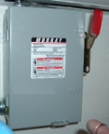 | 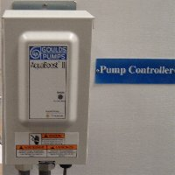
Goulds booster pump disconnect. | Pump controller.
Steps
NOTE: The following instructions are intended to highlight certain steps in this procedure. Specifications developed by Selecto Scientific may require additional steps.
- Coordinate Unit visit with Operator or manager. Contact Unit at least 48 hours prior to annual visit.
- Confirm with Operator or manager the complete array of cartridges to be replaced prior to visit.
- Inspect all filter housings for cracks and leaks before placing filter system in bypass in preparation for filter replacement.
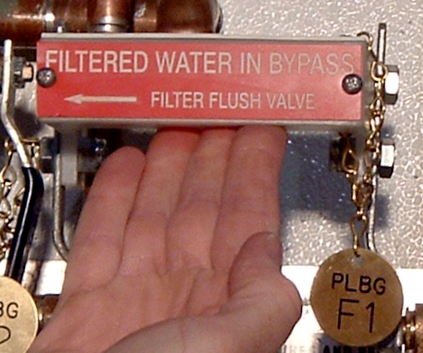

Steps (continued)
- Rinse all sumps with mild detergent.
- Lubricate sump O-rings with food grade silicon lubricant.
- Flush all carbon filter cartridges to drain for 4 minutes.
- Upgrade IcePRO S-10 and Scale Out feeder cartridges to 5 lb cartridge and bowl (first visit only). At this time, relocate feeder assembly as necessary to accommodate 5 lb cartridge.
- Inspect/adjust Goulds booster pump for constant 80 psi pressure.
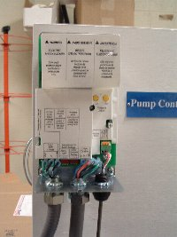 | 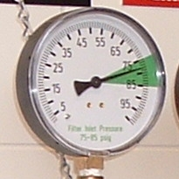
Pump controller with cover removed. | Filter system inlet gauge.

- Close filter system bypass and return system to normal operation.
Restrictions
- Expected completion date:
- Hours work can be conducted:
- Contractor will attend inspection with Operator/manager: YES NO
(Reminder: All changes must be communicated to and approved in advance by Facilities Department and Operator/manager of Unit.)

