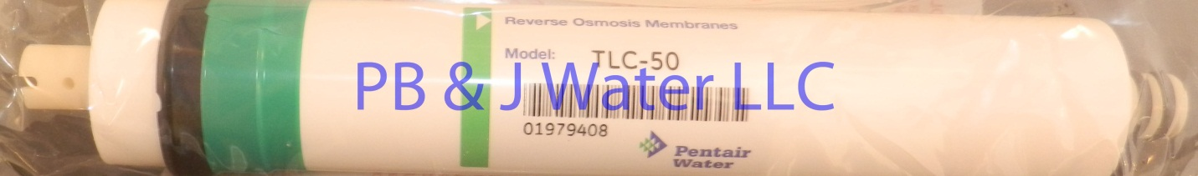

50 GPD membrane fits all standard residential Reverse osmosis systems