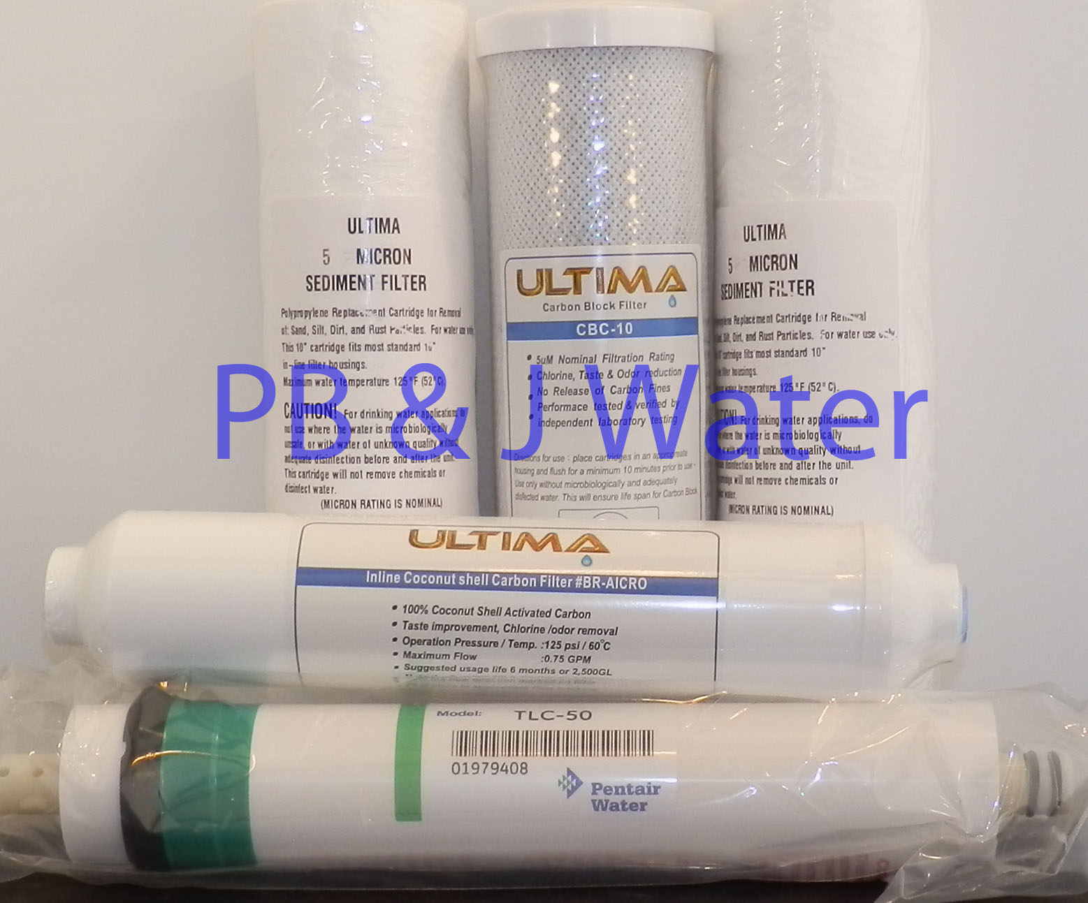

5 stage Reverse Osmosis water filtration replacement kit

1. 5 mic sediment water filter
2. 5mic carbon block water filter
3. 1 mic sediment water filter
4. Inline GAC ¼” female thread polish filter
5. 50 GPD membrane

